Chapter 7, Solution 59.

Determine the step response v_{o}(t) to v_{s} = 18 u(t) in the circuit of Fig. 7.124.

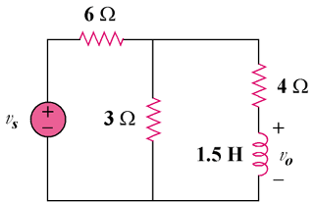

Figure 7.124
For Prob. 7.59.

Solution

Let i(t) be the current through the inductor.
For t < 0, ,
For t > 0, Ω and sec.

At t = ∞, the inductor becomes a short and the current delivered by the 18 volts source is I_{s} = 18/[6+(3||4)] = 18/7.714 = 2.333 amps. The voltage across the 4-ohm resistor is equal to 18–6(2.333) = 18–14 = 4 volts. Therefore the current through the inductor is equal to i(∞) = 4/4 = 1 amp.

amps.

[6e^{–4t}]u(t) volts.

